In the local server, create a directory to store repositories.
[eranda@devops ~]$ mkdir repos
[eranda@devops ~]$ ls -l
total 0
drwxr-xr-x. 2 eranda eranda 6 Jan 25 15:51 repos
[eranda@devops ~]$
Create a new repo on https://www.github.com.
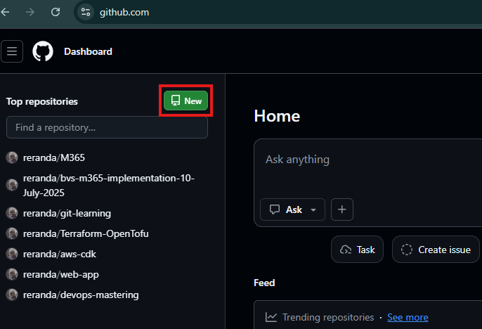
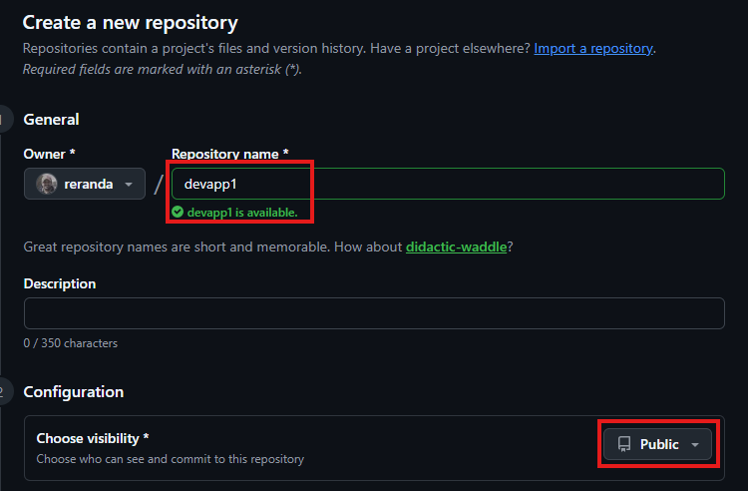
Clone this repo into the local server.
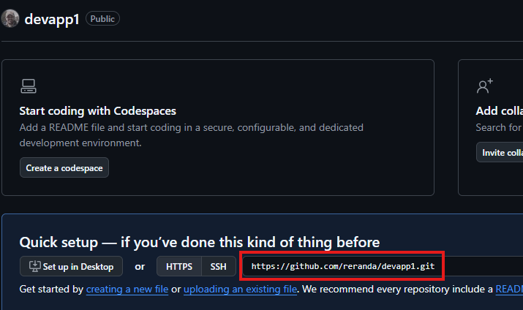
[eranda@devops ~]$ cd repos/
[eranda@devops repos]$ git clone https://github.com/reranda/devapp1.git
Cloning into 'devapp1'...
warning: You appear to have cloned an empty repository.
[eranda@devops repos]$ ls -l
total 0
drwxr-xr-x. 3 eranda eranda 18 Jan 25 16:04 devapp1
[eranda@devops repos]$
Link this repo with Visual Studio Code
Install following add-ons
- Remote SSH
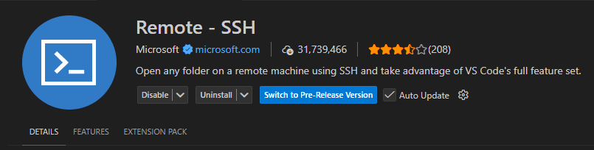
- GitHub Copilot
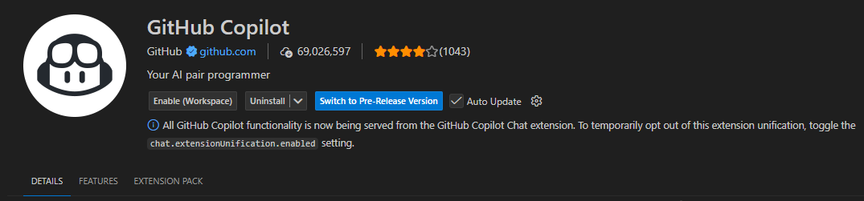
Click on Remote Explorer icon in the left-hand side of the tool bar.
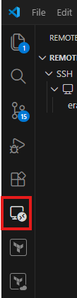
Click on + sign next to SSH
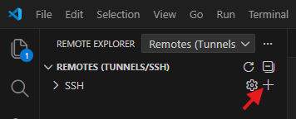
And enter eranda@192.168.8.210 (this is the local server IP address) and press Enter key.

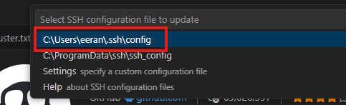
Click on Connect in New Window.
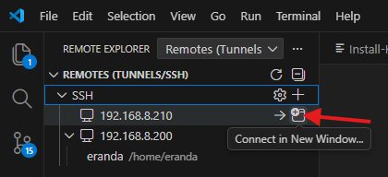
When it is prompt, select Linux.
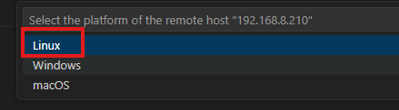
When it asks, please confirm to Continue and then enter the user’s password.
Click files icon on the left-hand side and click Open Folder button.
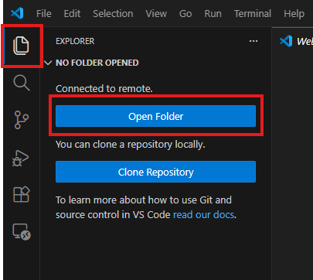
It will automatically select user’s home folder, so click OK.
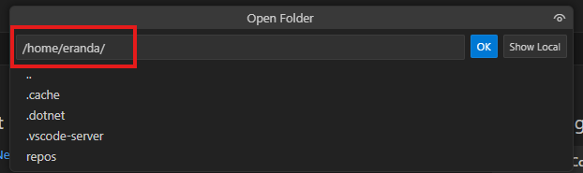
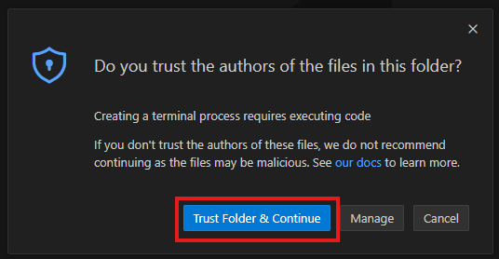
Then enter the user’s password.
Now you can see cloned repo in the user’s home folder. Right click on the repo and select Open in Integrated Terminal.
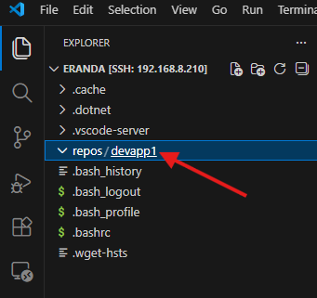
In the bottom right corner of the window, you will see similar icon to below, so click on it.
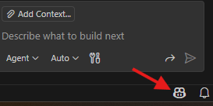
Once you click on it, select Enable AI Features button.
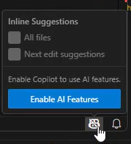
Then login in using GitHub account.
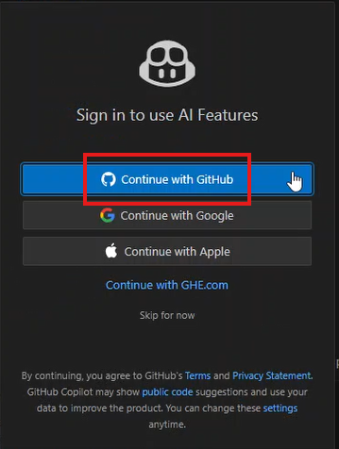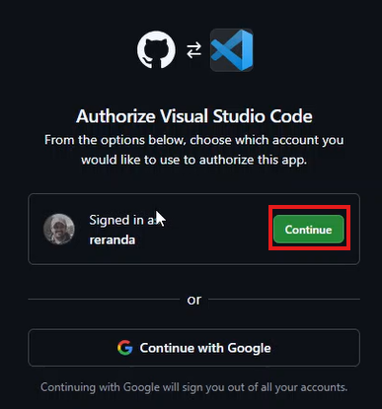
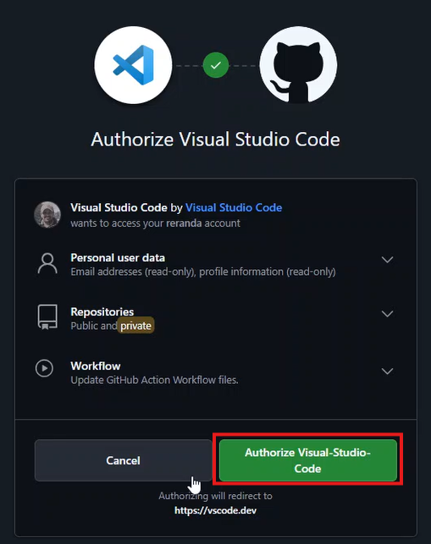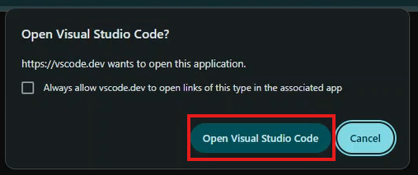
Click on the icon next to search bar on the top of Visual Studio Code, then select Open Chat from the menu.
Click on Add Context at the bottom of the Chat windows.
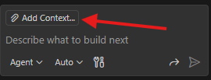
Then select Files and Folders… from the top search bar, and then select repos directory that you created before.
Now you can try at the chat windows whatever you want to ask. For an example, if you want to generate a simple web application, you can type, “Create a simple NodeJS + express web application which serve a Hello Word page.”
When you use this for the first time, it will ask for some modules to install, so allow them.
Once the new code is generated, you can see following button at the bottom of the chat windows, so click on it, so it will save the changes to the disk.
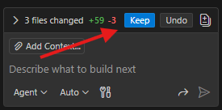
You may also have to install NodeJS and npm, so please install them.
[eranda@devops devapp1]$ sudo yum install nodejs npm
After that, you will have to install dependencies using npm to run the application.
[eranda@devops devapp1]$ npm install
Test the application.
[eranda@devops devapp1]$ npm install
Then go to browser and type; http://localhost:3000
Generate GitLab token to allow Visual Studio Code access GitLab repo.
Go to GitHub, click on profile icon and then click on Settings.
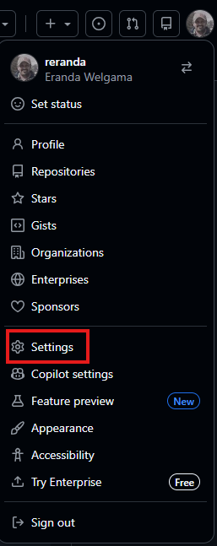
Go to bottom of the page and select Developer Settings from the left-hand list.
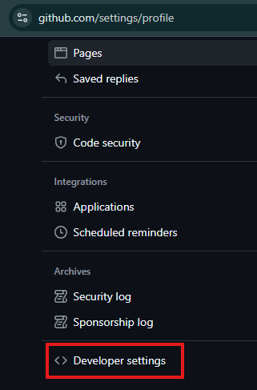
Expand Personal access token and click on Fine-grained tokens. Then click on Generate new token.
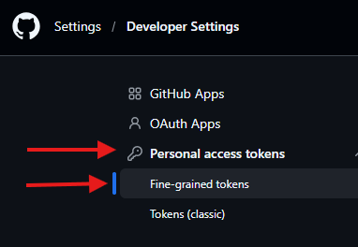
Fill in following and click on Generate token:
- Token name: <some_name>
- Expiration date: set some days such as 90 days
- Repository access: All repositories
- + Add permissions:
  - Metadata: Read-only
  - Actions: Read-only
  - Contents: Read and write
  - Pull requests: Read-only
First Git push
[eranda@devops devapp1]$ git config --global credential.helper cache
[eranda@devops devapp1]$ git config user.email "eeranda@gmail.com"
[eranda@devops devapp1]$ git config user.name "eranda-devops"
[eranda@devops devapp1]$ git add .; git commit -m "My first commit"; git push
Rename the repo to development.
Go to the repo in GitHub web interface and click Settings.
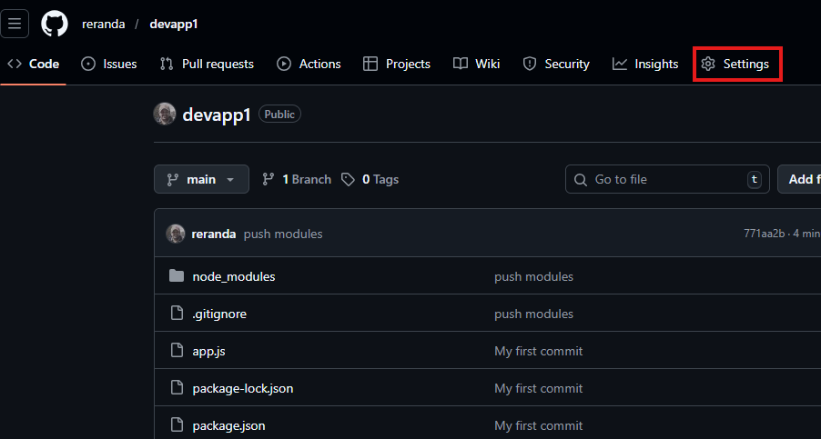
Under default branch, click edit button and then rename the branch from main to develop.
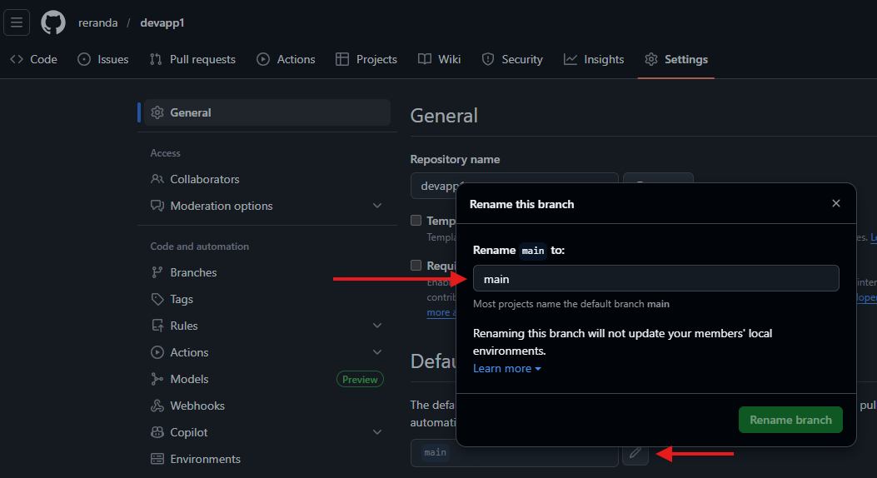
Click Rename branch.
Update the changes in the local copy.
[eranda@devops devapp1]$ git branch -m main develop
[eranda@devops devapp1]$ git fetch origin
[eranda@devops devapp1]$ git branch -u origin/develop develop
[eranda@devops devapp1]$ git remote set-head origin -a
[eranda@devops devapp1]$ git status
Clone example repo of Ranul
[eranda@devops repos]$ git clone https://github.com/Ranuldeepanayake/qba-back-end.git

